ABSTRACT TITLE

Author name¹, Author name², and Author name (Presenter underlined)
¹Author’s affiliation: 10 point type, centered, italicized
²Author’s affiliation: 10 point type, centered, italicized
Presenter’s e-mail address: 10 point type, centered, italicized

The 13th Annual International Workshop on Nanomechanical Sensing (NMC 2016) will be held in Delft, The Netherlands from 22 – 24 June, 2016. Since the inception of the meeting in 2004, it has been held around the world. This year we welcome you to Delft.
Abstracts for each contributed paper should be submitted electronically as PDF files by Monday, 7 March, 2016. Submission guidelines are on the workshop website at www.nmc-2016.org. The abstracts will be reviewed and acceptance notifications will be sent by Monday, 11 April 2016. All contributed papers will be considered for oral presentations unless a preference for poster presentation is indicated in the submission. Your document should have a total length no more than two pages. The abstracts will be published in the handbook that will be distributed among all workshop participants.
The conference topics include: instrumentation, biological sensors, chemical sensors, theoretical modelling of sensors, micro and nano fabrication, optomechanics and novel sensing platforms.
This template is used to format your paper and style the text. All margins, column widths, line spaces, and text fonts are prescribed; please do not alter them.
Define abbreviations and acronyms the first time they are used in the text, even after they have been defined in the abstract. Do not use abbreviations in the title unless they are unavoidable.
Number equations consecutively. Equation numbers, within parentheses, are to position flush right, as in (1), using a right tab stop. (you can make use of the template’s caption label ‘(‘, ‘Equation’ style and a tab before and after the equation. To make your equations more compact, you may use the solidus ( / ), the exp function, or appropriate exponents. Italic for quantities and variables and normal bold for vectors and matrices. Use a long dash (Em dash) rather than a hyphen for a minus sign. Punctuate equations with commas or periods when they are part of a sentence. If you are using Microsoft word, use equation editor to enter your equations. The resonance frequency of the cantilever is given as
$ω=\sqrt{\frac{k}{m}}$ ( 1 )
$ω-∆ω=\sqrt{\frac{k}{m+∆m}}$ ( 2 )
where, ω is angular frequency, k is stiffness, m is mass, Δω is frequency shift and Δm is mass change.
Be sure that the symbols in your equation have been defined before or immediately following the equation. Use “(1),” not “Eq. (1)” or “equation (1),” except at the beginning of a sentence: “Equation (1) is ...”
Place figures and tables at the top and bottom of columns. Avoid placing them in the middle of columns. Large figures and tables may span across both columns. Figure captions should be below the figures; table heads should appear above the tables. Insert figures and tables after they are cited in the text. Use the abbreviation “Fig. 1,” even at the beginning of a sentence.
- Table Styles
Table Head | Table Column Head
 | Table column subhead | Subhead | Subhead
copy | More table copyª
- Sample of a Table footnote.
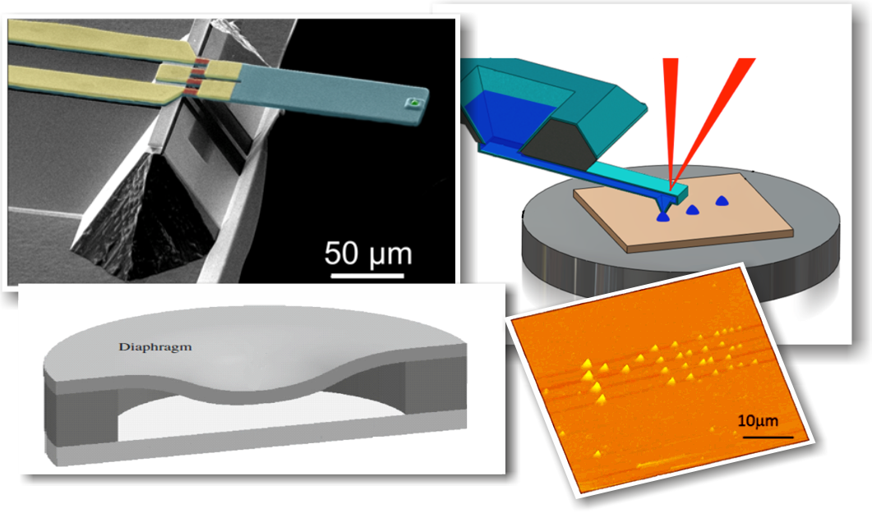
Fig. 1: Nanomechanical Sensing Devices. a) Cantilever, b) Membrane
Design details are left to the author’s discretion. If a table or figure is too wide to be contained in a single column, extend it over both columns, preferable at the top or bottom of a page. Figure Labels: Use 10 point Times New Roman italic for Figure labels. When using Word, use the ‘Fig.’ label caption style. Use words rather than symbols or abbreviations when writing Figure axis labels to avoid confusing the reader. As an example, write the quantity “Frequency” not just “F.” If including units in the label, present them within parentheses. Do not label axes only with units. In the example, write “Frequency (kHz)”. Do not label axes with a ratio of quantities and units. For example, write “Temperature (K),” not “Temperature/K”. Always insert scale bar in the pictures of a device, especially in the images from optical microscope, scanning electron microscope and atomic force microscope.
Headings are organizational guidelines for the reader of your paper. Component heads identify the different components of your paper and are not topically subordinate to each other. Examples include ACKNOWLEDGMENTS and REFERENCES. Text heads organize the topics on a relational, hierarchical basis. For example, the paper title is the primary text head because all subsequent material relates and elaborates on this one topic. If there are two or more sub-topics, the next level head should be used and, conversely, if there are not at least two sub-topics, then no subheads should be introduced. Do not insert page numbers in the abstract. An excellent style manual for science writers is written by Whitesides [1].
We look forward to see you in Delft, The Netherlands

ACKNOWLEDGMENTS
Avoid the stilted expression “one of us (N.M.C) thanks ...”. Instead, write “N. M. C. thanks...”.

REFERENCES
Use APA style for references. The template will number citations consecutively within brackets [1]. The sentence punctuation follows the bracket [2]. Refer simply to the reference number, as in [3]—do not use “Ref. [3]” or “reference [3]” except at the beginning of a sentence: “Reference [3] was the first ...”
Unless there are six authors or more give all authors’ names; do not use “et al.”. Papers that have not been published, even if they have been submitted for publication, should be cited as “unpublished” [2]. Papers that have been accepted for publication should be cited as “in press” [3]. Capitalize only the first word in a paper title, except for proper nouns and element symbols.
For papers published in translation journals, please give the English citation first, followed by the original foreign-language citation [4].
For websites as references, insert the entire address of the page. Make sure that the address works at the time of submission.

- Whitesides, G. M. (2004). Whitesides' group: writing a paper. Advanced Materials, 16(15), 1375-1377.
- S. Dalí, “Title of the paper,”, unpublished.
- K. Noble, “Title of the paper with only first word capitalized,” J. Name Stand. Abbrev., in press.
- Ghatkesar, M. K., et al. (2004, October). Real-time mass sensing by nanomechanical resonators in fluid. In Sensors, 2004. Proceedings of IEEE (pp. 1060-1063). IEEE.
- http://abacus.bates.edu/~ganderso/biology/resources/writing/HTWtoc.html

